8 Modifying Element Classes

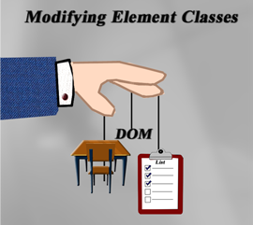

# Working with Classes

Now how if we wanted to work with classes using the DOM. We can do that by just adding a few classes to our HTML document.

In our HTML Document

Add this <div>

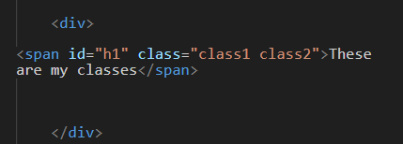

In our JavaScript document

We are going to use something called a classList to access our span with the id of “h1”. You can modify a whole lot of things by accessing the classList.

You can actually go to the website named [W3Schools classList](https://www.w3schools.com/jsref/prop_element_classlist.asp) to learn more about what you can modify using the classList.

# Adding a Class

However, for now we are just going to use “new” to add a new class.

spanhello.classList.add(“Da-class”)

Watch it, make sure that you have defined spanhello to be equal to the div using the id of hello. You must do this first by using the document.querySelector to find it.

Then we can target that span and add the class of “Da-class” to it.

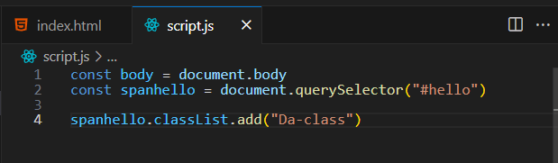

Now if you inspect the webpage in the browser, you will find that it did indeed add our new-class to the span.

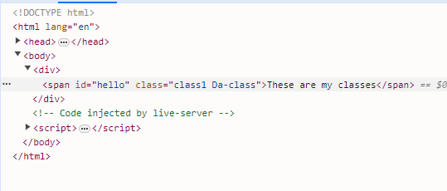

# Removing a Class

Here we can also remove a class from the span. Let’s try removing the class of class1, by using the remove method on it.

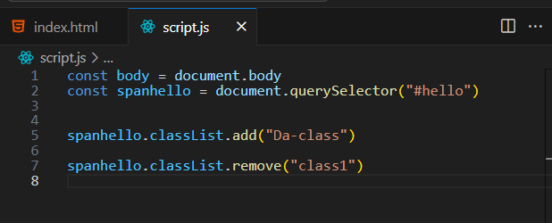

Now all that we have left is the class that we dynamically added.

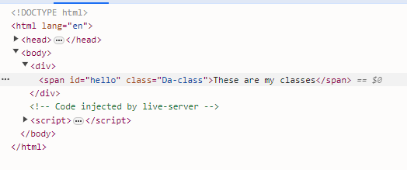

# Using Toggle

Toggle is a really useful method, because we can turn a class on or off. If the class is there is will remove it, and if it is not there it will add it.

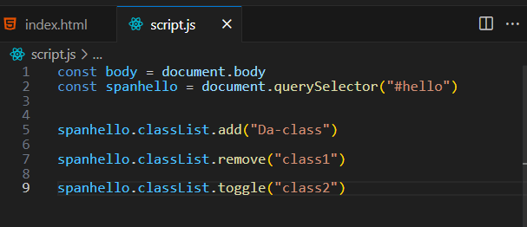

Since we did not have a class named class2 in the HTML, it added it. But if we had it there, it would have removed it.

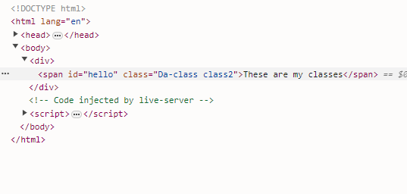

We can also pair this with a Boolean, which it will either add or remove the class depending on if it exists or not. If you put in false it will remove the class, and if you put in true, it will add the class.

Watch it, you do not want to surround the Boolean with quotation marks or it will not work. It is not text, it is a Boolean and Booleans do not use quotation marks.

